CareerCompass: A Machine Learning-Based IT Career Path Recommendation System with E-Portfolio for Bachelor of Science in Information Technology Students of Pamantasan ng Lungsod ng Pasig

A Capstone Project presented to the
College of Computer Studies of
Pamantasan ng Lungsod ng Pasig

In partial fulfillment of the requirements for the degree of
Bachelor of Science in Information Technology

By
Cogal, Daryl Iveen G.
Ramirez, John Gabriel
Salva, Alvin
Presented to:
Rebecca Fajardo
Adviser
June 2026
Table of Contents

CHAPTER 1: The Problem and Its Background
The Problem and Its Background 2
Review of Related Literature 6
Significance of the Study 14
Statement of the Problem 16
Scope and Limitation of the Study 18
CHAPTER 2: Methodology
Introduction 20
Research Design 20
Architectural Framework 21
Level 0 Data Flow Diagram (Context Diagram) 23
Algorithm Discussion 25
Software Engineering Paradigm 30
Population and Sampling 32
Data Collection Methods 33
Data Analysis Procedures 34
Ethical Considerations 35
Summary 36
References 37
CHAPTER 1
THE PROBLEM AND ITS BACKGROUND
The Problem and its Background
Choosing an appropriate career path for those who have chosen to pursue their degree in Information Technology (IT) is now arguably the most important decision that students can make within the ever-evolving technological environment. IT encompasses many different areas of specialization including, but not limited to, web development, software engineering, network engineering, data analysis and security. With increased demand on a global scale for qualified IT personnel, students are increasingly facing a broad number of possible career paths after graduating from college.
The impact of this indecision is far-reaching and quantifiable. According to the International Labor Organization (2023), the digital economy of the world is expanding faster than anyone could possibly have anticipated. Furthermore, there will be significant growth in IT-related jobs over the course of the coming decade. While this expansion creates abundant opportunities for individuals entering the field, it also amplifies the challenge faced by college students in determining which specific career within information technology best aligns with their individual skills, academic performance, certifications, and interests.
Several researchers have responded to this challenge with data-driven career guidance tools. Al-Dossari et al. (2020), for instance, proposed a machine learning-based recommendation system called CareerRec, which uses algorithms to help IT graduates select career paths based on their skills, demonstrating the effectiveness of data-driven approaches in career guidance. Building on this direction, Siswipraptini et al. (2024) developed a Personalized Career-Path Recommendation Model for Indonesian IT Students, illustrating how these types of systems could be used in a similar educational environment as that in the Philippines.
There are also other studies in the field of technology-assisted career guidance that do not focus on quantifiable score measures; they focus on non-quantitative forms of information. Specifically, there have been several studies examining whether or not the use of data-driven technologies to assist students with organizing evidence supporting student competency and exploring potential career paths can be helpful. The authors believe that pre-trained language models provide a viable means to evaluate the type of non-quantitative evidence typically included within the portfolios of students (i.e., project-based learning, reflective writing assignments, etc.) to identify which careers may best fit those students.
It is against this backdrop that the local context of this study takes shape. Pamantasan ng Lungsod ng Pasig (PLP) is an institution of higher learning with the main office situated in Pasig City, Metro Manila, Philippines. This institution provides quality education that aligns with current industry trends through its colleges to its diverse student body. Moreover, it has been recognized as one of the best institutions in terms of generating competitive graduates. In addition to other computing programs offered by the College of Computer Studies (CCS), the BSIT program is also part of those being offered. As such, approximately hundreds of students from various four-year levels enroll each semester into the BSIT program. The primary objective of this program is to develop graduates who are well-competent and have global competitiveness in their field of specialization as regards the information technology (IT) sector. Although the curricula of both programs are robust and comprehensive; there are no current accessible career guidance systems for BSIT students at PLP. Career guidance for these students is primarily based on general educational counseling rather than on specific guidelines related to a career in information technology.
In the absence of such a system, career decisions among BSIT students at PLP are commonly based on personal preference, advice from classmates, or information gathered informally from the internet. These resources will be useful in determining a direction in an IT Career; however, they are not objective evaluations of a Student's Academic Performance, Technical Skills, Certifications, Seminars Attended, Trainings Completed, and Career Interests as it relates to identifying the best suited IT Career Path. The preliminary findings from the student feedback collected by the researcher along with the review of the literature above indicates that developing a Data-Driven Recommendation System (DDRS) customized to the BSIT Program of Philippine Christian University could enable students to more accurately choose an appropriate IT career based upon their Competency and Credentials.
The cumulative results of these assessments indicate that there is a particular gap that this Study will address. There have been demonstrated examples of Career Recommendation Research utilizing Skill-Based Matching and Portfolio-Based Matching to assist IT Students in choosing an Appropriate Career Direction. Additionally, there have been demonstrated examples of student Profile Systems that have documented Student Competencies through E-Portfolios. However, there is no similar system for, nor has one been developed for use in conjunction with, the BSIT Program at Pamantasan ng Lungsod ng Pasig.
Without it, BSIT students remain uncertain about which competencies they should further develop to achieve their desired careers, a gap that can result in graduates entering fields that do not fully align with their competencies, leading to career dissatisfaction and reduced professional performance.
This study aims to address this gap through the development of CareerCompass, an NLP-assisted IT career path recommendation system with a student profile and e-portfolio assessment component, designed for BSIT students of Pamantasan ng Lungsod ng Pasig. Students can create accounts, provide their general weighted average (GWA), rate their interest in each of the five IT career tracks, and submit a text-based PDF portfolio or a public e-portfolio website. An important innovation in CareerCompass is how it utilizes a pre-trained sentence embedding model to extract relevant portfolio content and compares that to predefined descriptions of various IT career paths (i.e., a "career path" is defined as an aggregation of skills, knowledge areas and interests) by computing a portfolio similarity measure to each career path. These measures are then combined via a weighted synthesis with a student's GWA and interest ratings to compute their final ranked recommended career path(s), along with relevant detected skill evidence. A student can refresh the recommendation at any time when they submit new/updated portfolio content, GWA or interest ratings.
In addition to providing individual students with data-based career guidance information early on in their educational careers, CareerCompass will provide PLP with enhanced preparation of its graduates to meet the requirements of the IT industry, improved employment rates for PLP graduates, and greater overall success in its academic programs. Additionally, the Guidance Office and Faculty Advisers will have additional support using aggregated student data related to career readiness; this will enable them to identify and intervene earlier in students' academic careers and offer more focused career counseling.
Review of Related Literature
The growing complexity of career decision-making among students in the field of Information Technology has prompted researchers worldwide to explore intelligent and data-driven solutions. This section reviews the literature thematically: existing career recommendation systems; the algorithms and techniques such systems commonly use; existing platforms already available to students; semantic text matching as the specific technique adopted in this study; student profile systems in education; NLP- and AI-assisted tools in educational settings; and the career-path challenges reported among IT students. The section closes with a synthesis that situates CareerCompass within this body of work.

Career Recommendation System
Career recommendation systems have gained significant attention in recent years as institutions seek to provide students with more personalized academic and professional guidance. An intelligent career recommendation framework presented by IEEE Xplore (2024) leverages machine learning and data analytics to identify suitable career paths based on students’ academic performance, interests, and behavioral attributes. The study demonstrated that integrating supervised learning techniques with educational data mining can significantly enhance the accuracy and personalization of career recommendations.
In a related study, Al-Dossari et al. (2020) proposed CareerRec, a recommendation system trained on a dataset of over 2,000 IT-sector employees, which used machine learning algorithms to match graduates’ skills with appropriate career tracks. The study illustrates the value of relating a learner’s demonstrated skills to clear career descriptions. CareerCompass applies this principle differently: rather than training a classifier on a labeled employee dataset, it compares the semantic content of a student’s e-portfolio with predefined descriptions of five IT career tracks using a pretrained language model, which removes the dependency on a large labeled dataset that a supervised approach like CareerRec’s would require.

Recommendation Algorithms and Techniques
Career-recommendation systems in the literature are typically built on one of a few families of algorithms, and the choice among them shapes both what data a system needs and what kind of “machine learning” claim it can honestly make. Content-based filtering methods, such as the decision-tree-based CART algorithm (Shang, 2023) used in several student-advising and career-planning tools, learn a mapping from a student’s structured attributes (grades, test scores, categorical interests) to a predicted class label, but they require a sizable labeled training set of past students matched to verified outcomes before they can be trusted something not yet available for the PLP BSIT population. Collaborative filtering methods, common in commercial recommender systems (Ricci et al., 2011), infer suggestions from patterns across many other users’ choices, which similarly depends on a large existing user base that a first-deployment system does not have. Semantic similarity methods, by contrast, use a pretrained sentence-embedding model (e.g., Sentence-BERT and its distilled variants such as all-MiniLM-L6-v2) to represent both a student’s portfolio text and each career description as vectors, then rank career tracks by cosine similarity between them. Because the language understanding is already learned during the model’s pretraining, this approach can produce meaningful rankings without first collecting a labeled dataset of PLP students at the cost of not being a classifier that learns from the institution’s own data over time.
CareerCompass adopts the semantic similarity approach for this reason: it is the technique that best fits a first deployment with no existing labeled dataset of BSIT student outcomes, while still being grounded in the same embedding techniques (Sentence-BERT, MiniLM) used by the wider career-recommendation literature discussed above. This is also why the system is described in this study as NLP-based and semantic-matching-based rather than as a trained machine-learning classifier: the recommendation logic combines a pretrained language model with a transparently weighted formula, not a model fitted to PLP’s own student data. Section “Algorithm Discussion” in Chapter 2 details this mechanism, and the Future Researchers subsection of the Significance of the Study notes CART as a natural next step once a sufficiently large labeled dataset of PLP BSIT outcomes becomes available.

Existing Related Systems
Beyond the research prototypes reviewed above, students today already have access to a handful of publicly available career-guidance tools, and reviewing them clarifies what gap CareerCompass specifically fills. The O*NET Interest Profiler, maintained by the U.S. Department of Labor, matches users to broad occupational interest categories through a self-report questionnaire; it is widely used but is not IT-specific, does not consider academic performance, and has no mechanism for evaluating a portfolio of actual project work. LinkedIn’s Skill Assessments and Career Explorer features similarly help users benchmark specific technical skills and browse career paths based on their existing profile, but they rely on self-reported skills and multiple-choice testing rather than an analysis of a student’s own documented project work, and they are not tailored to any particular curriculum or institution.
Closer to an academic setting, several Philippine higher-education institutions have implemented locally built student-tracking or advising systems, but these are typically limited to monitoring grades, attendance, and enrollment rather than generating a career recommendation from a student’s demonstrated competencies. None of the systems reviewed combine GWA, self-rated interest, and semantic analysis of an e-portfolio into a single ranked recommendation, and none are built specifically for the BSIT population and career tracks offered at PLP. This absence is the specific, concrete gap CareerCompass is designed to close.

Semantic Portfolio Matching
Semantic portfolio matching is an information-retrieval approach that represents text as numeric embeddings and compares the embeddings to identify similar meanings. Sentence-BERT is a sentence-embedding architecture designed to produce representations suitable for efficient semantic similarity comparison (Reimers & Gurevych, 2019). Unlike a classifier trained on local student records, this approach uses a pretrained model to interpret the language in a portfolio, which is what allows CareerCompass to function without first collecting a labeled outcomes dataset.
In CareerCompass, readable text is extracted from a student’s text-based PDF portfolio or public e-portfolio website. The system embeds that text and the fixed descriptions for Software Engineering, Web Development, Data Science and Analytics, Cybersecurity, and Network Engineering using the all-MiniLM-L6-v2 sentence-transformer model, a compact transformer architecture based on MiniLM (Wang et al., 2020). Cosine similarity is then used to rank the career descriptions by their semantic closeness to the submitted portfolio, and the resulting scores are rescaled so they fall within a consistent range before being combined with the student’s GWA and self-rated career interests through a weighted synthesis, as detailed in Chapter 2. The displayed score is a similarity-based ranking indicator, not a probability of career success.
Semantic matching is useful when students present their competencies through project descriptions, technology lists, and narrative portfolio content rather than through a fully labeled training dataset. It also permits the system to provide simple supporting evidence by identifying relevant career keywords found in the submitted text. If the semantic model is unavailable, CareerCompass uses transparent keyword skill matching as a fallback so that the portfolio-analysis feature remains available.

Student Profile System in Education
A student profile system is a digital collection of a student’s academic achievements, credentials, and personal reflections that serves as both a learning tool and an assessment instrument (Lorenzo & Ittelson, 2005). In the context of higher education, student profile systems have been widely adopted as a means of capturing the holistic development of students beyond what traditional academic records can reflect.
Tosh et al. (2005) highlighted that student profile systems enable students to document their learning journey, including academic performance, certifications, co-curricular activities, and professional development experiences such as seminars and trainings. Such documentation can provide useful context for career guidance. In CareerCompass, the e-portfolio is the primary recommendation input because it contains project descriptions and skill evidence that can be compared semantically with the available IT career tracks.

NLP- and AI-Assisted Tools in Educational Settings
The application of AI-assisted tools in education has expanded beyond academic-performance prediction to encompass career planning, learning-style detection, and student-success forecasting. Machine-learning-assisted career tools can help organize student evidence and present relevant career options, provided that their recommendations are communicated as guidance and not as final decisions.
Furthermore, Wan and Ye (2022) explored career recommendation for college students using machine learning approaches, demonstrating that data-informed recommendations can be actionable when based on relevant learner evidence. For CareerCompass, semantic comparison of e-portfolio content pursues this same goal through a different mechanism a pretrained NLP model rather than a locally trained classifier which allows the study to draw on this broader literature’s findings about data-informed guidance without requiring a labeled dataset of student career outcomes.

IT Career Path Challenges Among Students
Several studies have identified that students pursuing IT-related programs often face significant uncertainty regarding career specialization. Siswipraptini et al. (2024) specifically addressed this issue in the context of Indonesian IT students, noting that the absence of personalized guidance systems forces students to rely on subjective inputs rather than evidence-based recommendations. Their proposed model, which accounts for individual competencies and preferences, demonstrated improved alignment between student profiles and career outcomes.
Similarly, a study by Cui (2024), published in the Journal of Electrical Systems, highlighted that career interest assessments grounded in machine learning provide college students with more reliable career planning tools compared to traditional counseling approaches. The study emphasized that data-driven systems reduce the influence of cognitive biases in career decision-making, a finding particularly relevant to the Philippine educational context where formal IT career counseling infrastructure remains underdeveloped.

Synthesis
The literature reviewed above converges on three points that directly justify the design of CareerCompass. First, career-recommendation systems demonstrably improve on informal, subjective career decision-making both international studies (Al-Dossari et al., 2020; IEEE Xplore, 2024) and studies set in comparable Southeast Asian academic contexts (Siswipraptini et al., 2024) support this. Second, the algorithm families available for building such systems trade off differently between accuracy potential and data requirements: supervised classifiers such as CART offer strong performance once trained but require labeled outcome data this study does not yet have, while pretrained semantic-embedding models such as Sentence-BERT (Reimers & Gurevych, 2019) and MiniLM (Wang et al., 2020) can operate immediately on unstructured portfolio text without that requirement. Third, no existing platform whether a general-purpose tool like O*NET or LinkedIn, or a locally built PLP system combines academic performance, self-rated interest, and semantic e-portfolio analysis into one recommendation tailored to the BSIT program specifically.
CareerCompass is positioned at the intersection of these three findings: it applies the semantic-matching technique best suited to a first deployment without labeled outcome data, grounded in the same pretrained-embedding literature used elsewhere in career recommendation research, to close the specific institutional gap identified for PLP BSIT students. This positioning also explains why the study is described as NLP-based and semantic-matching-based rather than as a machine-learning classifier: the contribution is the application and integration of an existing pretrained model into a portfolio-based recommendation pipeline for this student population, not the training of a new supervised model. The chapter that follows details how this pipeline is implemented and evaluated.
Significance of the Study
The development of CareerCompass: A Machine Learning-Based IT Career Path Recommendation System with Student Profile System is expected to provide meaningful contributions to various stakeholders. The following groups stand to benefit from this research:
Pamantasan ng Lungsod ng Pasig (PLP)
The institution will benefit from CareerCompass by gaining a practical, data-driven tool that can be integrated into its student services and academic advising framework. The system will allow the university to better understand the career readiness and skill distribution of its BSIT student population, enabling the College of Computer Studies to design more targeted curriculum interventions and industry linkage programs that align with actual student competencies and career demand.
Guidance Office
The Guidance Office of PLP will benefit from CareerCompass through access to a centralized dashboard that presents aggregated data on student career inclinations, academic performance, certifications, and training records. This data will support more structured and evidence-based career counseling sessions, enabling the Guidance Office to identify students who may need additional career support and to align their counseling services with the actual career trajectories of BSIT graduates.
BSIT Students
The primary beneficiaries of this system are the Bachelor of Science in Information Technology students of PLP. Students can create accounts, complete the assessment, and submit an e-portfolio in text-based PDF form or through a public website. The system provides a ranked IT career recommendation based on a weighted combination of the semantic similarity between their portfolio content and the available career-track descriptions, their GWA, and their self-rated career interests, helping them reflect on their skills and professional development.
Faculty and Academic Advisers
Faculty members and academic advisers will benefit from CareerCompass through access to aggregated insights on student skill profiles and career inclinations. This data will support more meaningful advising sessions and enable faculty to provide targeted mentorship aligned with each student's recommended career direction.
The Researchers
This study will enhance the technical and research competencies of the researchers, particularly in semantic text matching, e-portfolio analysis, student profile system development, Python and Flask web development, and academic writing. The experience gained will serve as a strong foundation for future professional and research endeavors in these areas.
Future Researchers
This study may serve as a reference and basis for future research involving career recommendation systems, semantic portfolio analysis, student profile system integration in higher education, and machine learning in student guidance. Future researchers may expand the career profiles, evaluate recommendation quality with users, or develop a supervised model when an appropriate labeled dataset becomes available.
Statement of the Problem
BSIT students of Pamantasan ng Lungsod ng Pasig currently lack access to a structured and data-driven system that can guide them in identifying the most suitable IT career path based on their individual academic performance, technical skills, and portfolio evidence such as certifications and trainings.. The absence of such a system results in students relying on informal and often subjective sources of career guidance, which may lead to misalignment between their competencies and their chosen career specialization.
Specifically, this study seeks to answer the following questions:
- What student profile information and career-related factors are required to recommend the most suitable IT career path for BSIT students?
- How can student GWA, career interests, and e-portfolio content including any certifications, seminars, and trainings documented within it be collected, managed, and used to generate personalized IT career path recommendations?
- What NLP-based semantic matching approach can be used to compare and recommend the most suitable IT career path based on the collected student profile data?
- How can the system provide dashboards and reports that enable students, faculty advisers, and the Guidance Office to monitor skills, career readiness, and recommended IT career paths for students?
- How acceptable is the developed CareerCompass system in terms of the ISO/IEC 25010 software quality characteristics as evaluated by BSIT students, faculty members, and the Guidance Office of Pamantasan ng Lungsod ng Pasig?
Scope and Limitation of the Study
Scope
CareerCompass currently includes the following features and functionalities:
- User authentication with email verification for registration, login, logout, password reset, and password change.
- Student profile management for name, year level, section, phone number, age, and account details.
- Career assessment submission using the student's GWA and selected career-interest options.
- Portfolio analysis from a text-based PDF e-portfolio, a public portfolio website, or both.
- Career matching that ranks the five IT career tracks supported by the system: Software Engineering, Web Development, Data Science & Analytics, Cybersecurity, and Network Engineering.
- Personalized recommendation results that show the top career match, alternative tracks, match scores, and a written explanation of the recommendation.
- Student dashboard, recommendation page, assessment page, history page, and profile page for tracking results and updating information.
- Faculty and administrator access to student records, submitted assessments, and recommendation summaries.
- Faculty dashboard tools for viewing student lists, recent recommendations, recommendation distribution, and assessment completion summaries.
- Faculty notes for recording adviser feedback on student records.
- Shared web pages served through the Flask application, with assessment and recommendation data stored in SQLite.
Limitation
The study, however, is subject to the following limitations. The system will only cover BSIT students of Pamantasan ng Lungsod ng Pasig and will not be extended to other degree programs or institutions during the study period. The quality of a recommendation depends on the completeness, clarity, and relevance of the readable portfolio content submitted by the student. The system will not integrate real-time job-market data, salary benchmarks, or a locally trained predictive model. Its weighted recommendation scores are guidance indicators and must not be interpreted as validated probabilities, career-outcome predictions, or professional counseling.

CHAPTER 2
METHODOLOGY
Introduction
This chapter presents the methods, procedures, and tools used to develop and evaluate CareerCompass, a web-based IT career path recommendation system for BSIT students of Pamantasan ng Lungsod ng Pasig. It explains how the study was designed, how portfolio data were gathered and analyzed, and where the architectural framework, Level 0 DFD, algorithm flowchart, and confusion matrix should be placed in the chapter.
The purpose of this chapter is to present the research design, architectural framework, algorithm, population and sampling procedure, data collection methods, data analysis procedures, and ethical considerations that guided the development of CareerCompass. Presenting these elements in enough detail allows another researcher to understand, replicate, or extend the recommendation process described in this study.
Research Design
This study employed a descriptive-developmental research design. The descriptive component was used to identify the system requirements, target users, portfolio inputs, and career-track criteria, while the developmental component guided the design and implementation of the CareerCompass web application. This design is suitable for the study because it allows the researchers to describe the existing career-guidance problem among BSIT students and at the same time develop a system that addresses that problem through a structured recommendation process.
The descriptive component of the design was used to identify and document the requirements of BSIT students, the Guidance Office, and faculty advisers, including the profile information, portfolio inputs, and the five IT career-track descriptions that the system compares against submitted portfolios. The developmental component, on the other hand, guided the actual design, coding, and testing of the CareerCompass web application, from the database schema up to the semantic-matching pipeline and the role-based dashboards. Creswell and Creswell (2018) note that combining descriptive and developmental elements in a single design is appropriate when a study must both understand a problem and produce a working solution that addresses it, which reflects the twofold objective of this research: to describe the career-guidance gap among BSIT students and to develop CareerCompass as a response to that gap.
Architectural Framework
The CareerCompass system follows a three-tier architecture composed of the Presentation Layer, the Application Logic Layer, and the Data Layer. The Presentation Layer contains the student, faculty, guidance, and administrator interfaces that allow users to register, sign in, manage profiles, submit their GWA, career-interest ratings, and portfolios, and view recommendations. The Application Logic Layer, built on a Flask application server, handles authentication, text extraction, semantic similarity scoring through the all-MiniLM-L6-v2 sentence-transformer model, the keyword matching fallback, min-max rescaling of the portfolio similarity scores, and the weighted synthesis of the portfolio, interest, and GWA sub-scores into a final ranked recommendation. The Data Layer stores user accounts, student profile records, verification codes, faculty notes, and recommendation history in SQLite.
Figure 2. Architectural Framework of the CareerCompass System
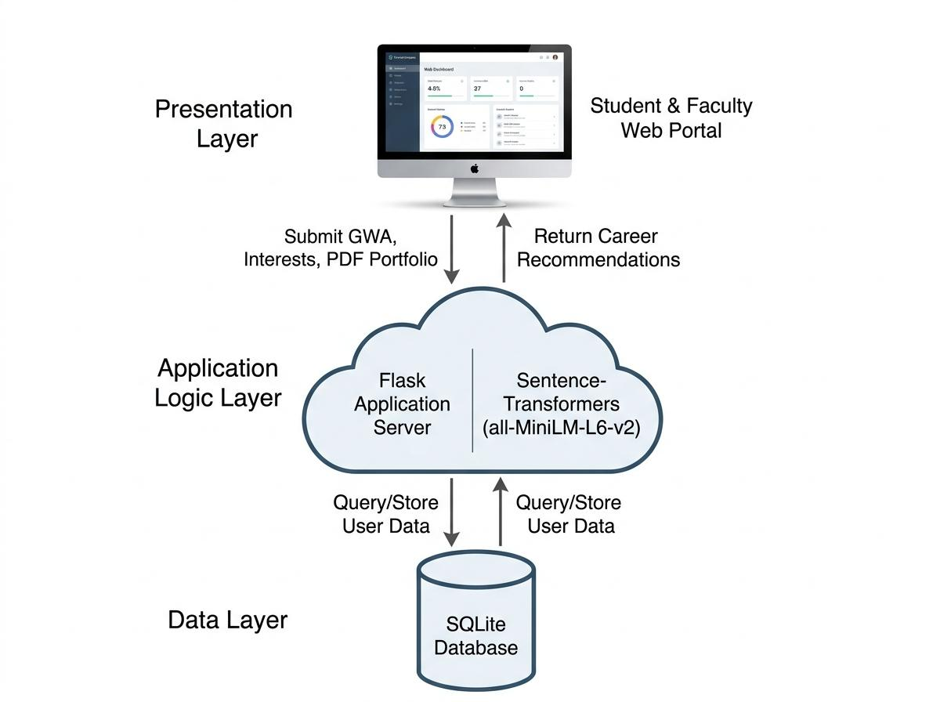
Within the Presentation Layer, separate interfaces are provided for students, faculty advisers, Guidance Office staff, and system administrators so that each user role only sees the screens and data relevant to their function. The student interface is where GWA, career-interest ratings, and the PDF portfolio or e-portfolio link are submitted, and where the ranked recommendation is returned. The Application Logic Layer is responsible for validating this input, extracting readable text from PDF and web-based portfolios, generating sentence embeddings, computing cosine similarity scores, rescaling those scores, applying the keyword matching fallback when the semantic model cannot be reached, computing the weighted synthesis of the portfolio, interest, and GWA sub-scores, and assembling the dashboard summaries used by faculty and the Guidance Office. The Data Layer uses SQLite because it is a lightweight, file-based relational database that is sufficient for the volume of records expected from a single-institution deployment and does not require a separate database server to be installed and maintained. This layered separation follows standard three-tier design practice, which keeps the interface, business logic, and data storage independent so that each layer can be modified, such as replacing SQLite with a larger database engine in a future deployment, without requiring major changes to the others.
Level 0 Data Flow Diagram (Context Diagram)
The Level 0 Data Flow Diagram shows the three main external entities that interact with CareerCompass: the BSIT Student, the Faculty/Adviser, and the System Administrator/Guidance Office. The BSIT Student submits profile details and portfolio content and receives a personalized career recommendation in return. The Faculty/Adviser sends advising feedback notes and receives the student performance directory. The System Administrator/Guidance Office sends system configurations and account actions and receives aggregated career inclination reports. The core process is the CareerCompass web application, which receives student, faculty, and administrator input, processes it, and returns the corresponding recommendation, directory, and report outputs.
Figure 3. Level 0 Data Flow Diagram (Context Diagram) of CareerCompass
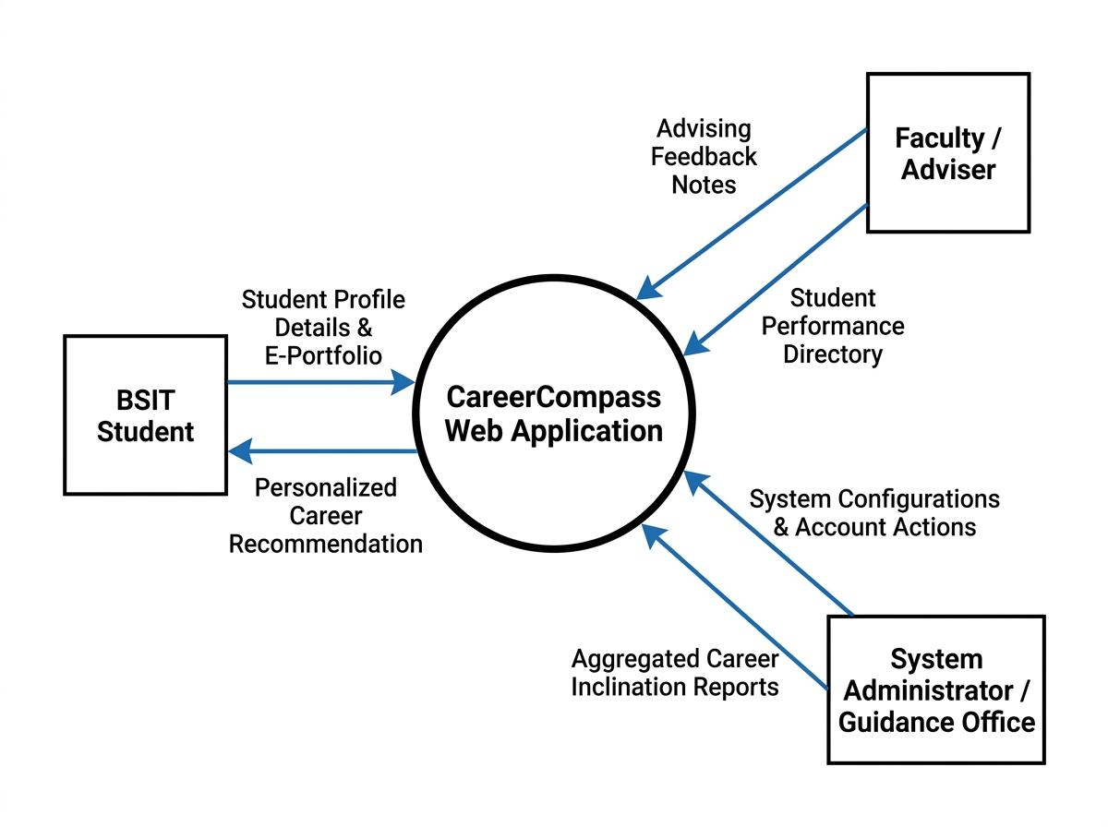
Each of the three external entities has a distinct data exchange with the system. The BSIT Student sends student profile details and e-portfolio content, and receives a personalized career recommendation. The Faculty/Adviser sends advising feedback notes and receives the student performance directory, which supports more targeted mentoring. The System Administrator/Guidance Office sends system configurations and account actions, such as creating or updating accounts and adjusting system settings, and receives aggregated career inclination reports that summarize student career tendencies for institution-level planning. Representing these three entities and their exchanges at Level 0 keeps the diagram at a system-wide view; lower-level diagrams may later decompose the CareerCompass process into its extraction, embedding, rescaling, and weighted-synthesis sub-processes.
Algorithm Discussion
The recommendation algorithm begins when a student submits the career assessment form, which includes the student's GWA, a self-rated interest level for each of the five career tracks, and a PDF portfolio or a public e-portfolio link. The GWA and interest ratings are processed directly into numeric sub-scores, while the portfolio is handled separately: PDF text is extracted with PyMuPDF, and public website text is captured with requests and BeautifulSoup. According to Wang et al. (2020), the extracted portfolio text can be converted into embeddings using the all-MiniLM-L6-v2 sentence-transformer model. For example, if a student portfolio contains repeated evidence of Python programming, web development projects, and data-analysis work, the system compares that text against the career-track descriptions and ranks Data Science and Analytics, Software Engineering, Web Development, Cybersecurity, and Network Engineering according to semantic similarity. Al-Dossari et al. (2020) and Wan and Ye (2022) support the use of career-description matching in this kind of recommendation flow.
The system also records supporting skill evidence by identifying relevant keywords and phrases in the submitted text. When the semantic model is unavailable, the keyword matching fallback keeps the portfolio-analysis feature active so the recommendation pipeline still works.
Because raw cosine similarity values tend to cluster in a narrow range and rarely reach 0 or 1 in practice, the five portfolio similarity scores are rescaled using min-max normalization to a 45%-95% range before they are used any further. This keeps the displayed portfolio score from looking like an absolute pass or fail while still preserving the relative ranking among the five career tracks. The rescaled portfolio score for each track is then combined with the student's GWA sub-score and interest sub-score for that same track using a weighted synthesis of 65% portfolio, 20% interests, and 15% GWA. The portfolio component is weighted most heavily because it reflects demonstrated project work, while the interest and GWA components adjust the ranking toward tracks the student is both motivated to pursue and academically prepared for.
The GWA sub-score used in this weighted synthesis is computed with the Academic Readiness Score formula implemented in the system:
Academic Readiness Score = ((5.00 − GWA) / 4.00) × 100
which maps the Philippine university GWA scale, where 1.00 is the highest possible grade and 5.00 is the lowest, onto a 0%-100% readiness score. Under this formula, a GWA of 1.00 converts to a 100% score, a GWA of 2.00 converts to 75%, a GWA of 3.00 converts to 50%, and a GWA of 5.00 converts to 0%. The system's top-ranked track for a given portfolio will later be evaluated against expert judgment (see Data Analysis Procedures), rather than against a trained classifier, since no supervised model is fit to PLP's own student data in this pipeline.

Figure 4. Algorithm Flowchart of the Semantic Portfolio Matching Process

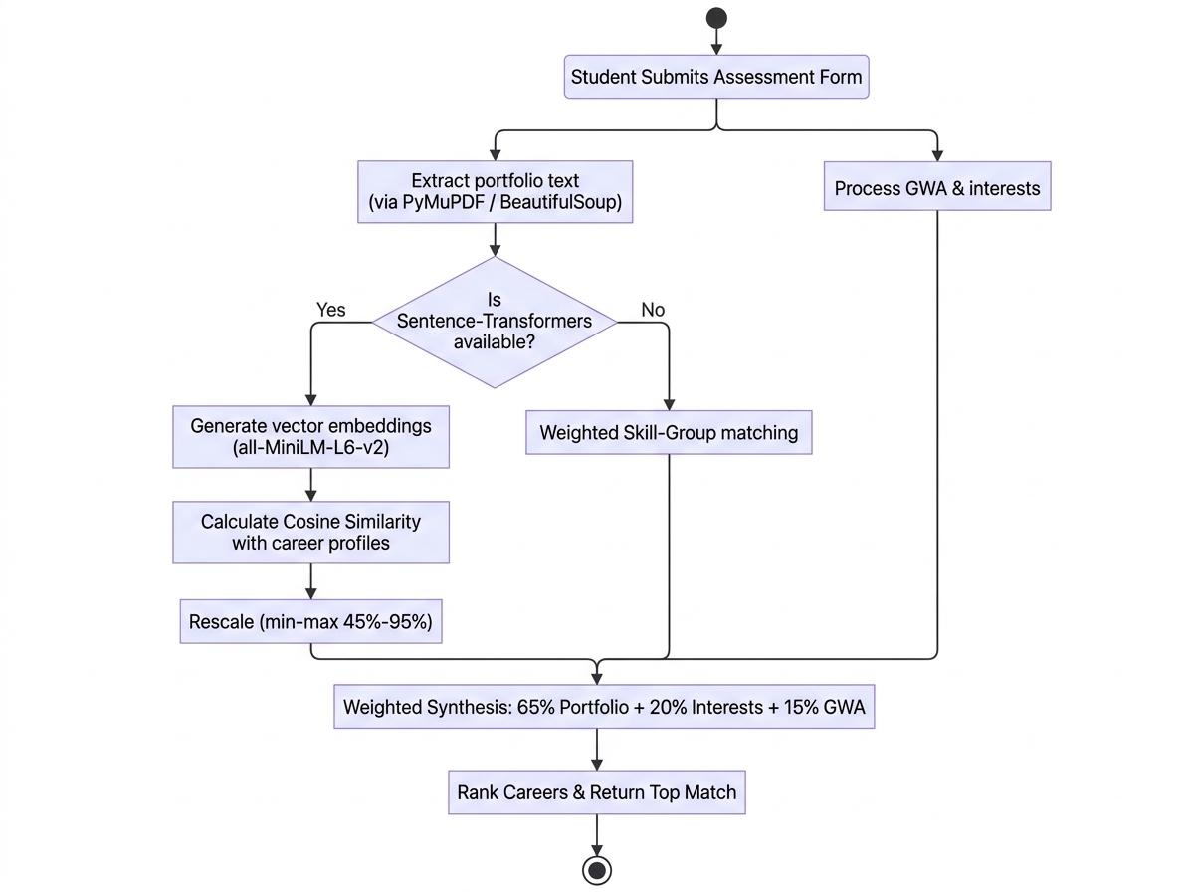
For validation, the top recommendation is compared against labeled sample portfolios or expert-reviewed cases. The system then computes accuracy, precision, recall, F1-score, and a confusion matrix to show how often the recommended track matches the expected track and where misclassifications occur. This makes the performance of the recommendation process easier to interpret for both students and evaluators.
To illustrate how the ranking is produced, cosine similarity is computed as the cosine of the angle between two embedding vectors:
similarity(A, B) = (A · B) / (||A|| × ||B||)
where A is the embedding of the submitted portfolio text and B is the embedding of a career-track description, A · B is the dot product of the two vectors, and ||A|| and ||B|| are their magnitudes. A value close to 1 indicates that the portfolio and the career description are semantically close, while a value close to 0 indicates little semantic overlap.
Consider a simplified example using three-dimensional vectors for illustration; the actual system produces 384-dimensional vectors from the all-MiniLM-L6-v2 model. Suppose a student's portfolio contains repeated mentions of “Python,” “data visualization,” and “regression model,” and its embedding is represented as A = [0.62, 0.55, 0.41]. The Data Science and Analytics career description embeds to B₁ = [0.60, 0.58, 0.39], while the Network Engineering description embeds to B₂ = [0.10, 0.22, 0.85].
1. Dot product of A and B₁ = (0.62×0.60) + (0.55×0.58) + (0.41×0.39) = 0.372 + 0.319 + 0.160 = 0.851
2. Magnitude of A = √(0.62² + 0.55² + 0.41²) = √(0.384 + 0.303 + 0.168) = √0.855 ≈ 0.925
3. Magnitude of B₁ = √(0.60² + 0.58² + 0.39²) = √(0.360 + 0.336 + 0.152) = √0.848 ≈ 0.921
4. Cosine similarity(A, B₁) = 0.851 / (0.925 × 0.921) ≈ 0.851 / 0.852 ≈ 0.999
Following the same steps for B₂: the dot product is (0.62×0.10) + (0.55×0.22) + (0.41×0.85) = 0.062 + 0.121 + 0.349 = 0.532; the magnitude of B₂ = √(0.010 + 0.048 + 0.723) = √0.781 ≈ 0.883; and cosine similarity(A, B₂) = 0.532 / (0.925 × 0.883) ≈ 0.532 / 0.817 ≈ 0.651.
Because the similarity score between the portfolio and Data Science and Analytics (≈ 0.999) is higher than the score between the portfolio and Network Engineering (≈ 0.651), Data Science and Analytics is ranked ahead of Network Engineering for this student. The same computation is repeated for all five career-track descriptions, and the tracks are then displayed to the student in descending order of similarity score, together with the keywords detected in the portfolio text as supporting evidence.
Continuing the example, suppose the cosine similarity scores for all five career tracks are min-max normalized and rescaled to the 45%-95% range, and Data Science and Analytics receives the highest rescaled portfolio score of 95%. If the same student rated their interest in Data Science and Analytics at 90% and has a GWA of 1.32, the Academic Readiness Score formula converts this to a GWA sub-score of ((5.00 − 1.32) / 4.00) × 100 = 92%. The final weighted score for that track is then computed as: (0.65 × 95) + (0.20 × 90) + (0.15 × 92) = 61.75 + 18.00 + 13.80 = 93.55%. The same computation is repeated for the remaining four tracks, and CareerCompass displays the tracks to the student in descending order of this final weighted score, together with the keywords detected in the portfolio text as supporting evidence.
Software Engineering Paradigm
The development of CareerCompass follows an Agile, iterative, and incremental paradigm. Requirements are refined from Chapter 1, the system is implemented in small modules, and each module is reviewed before the next increment is added. According to Pressman and Maxim (2020) and Schwaber and Sutherland (2020), this approach supports rapid adjustment of the dashboard, extraction logic, and recommendation flow based on testing feedback.
Figure 5. Software Development Life Cycle (SDLC)
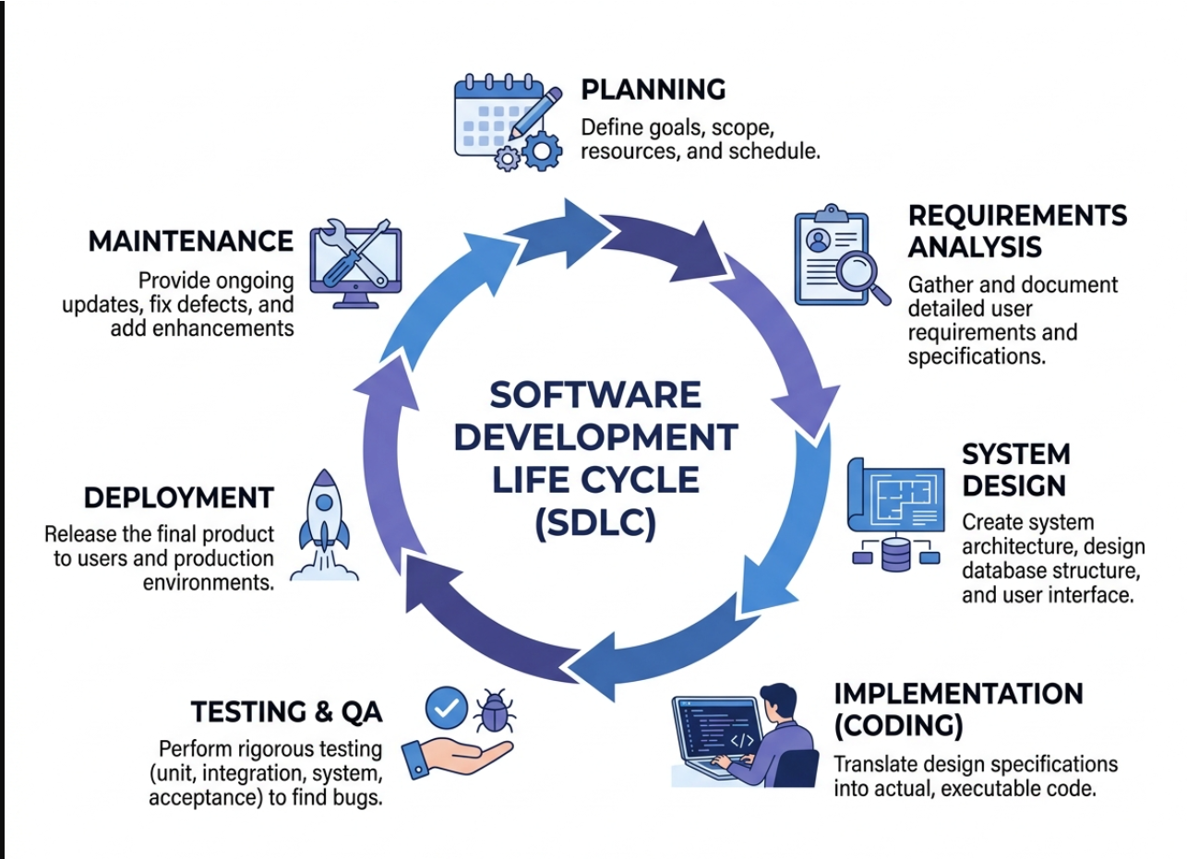
The project followed the seven phases of the Software Development Life Cycle shown in Figure 6: Planning, Requirements Analysis, System Design, Implementation, Testing and QA, Deployment, and Maintenance. Planning defined the project goals, scope, and schedule, while Requirements Analysis, informed by Chapter 1, gathered the detailed user requirements of BSIT students, faculty advisers, and the Guidance Office. System Design covered the three-tier architecture, database schema, and interface layout described earlier in this chapter, and Implementation translated those design specifications into the Flask application, the extraction and embedding pipeline, and the student, faculty, and administrator interfaces. Testing and QA covered unit, integration, system, and acceptance testing of the recommendation pipeline and dashboards, Deployment released the working prototype for evaluation, and Maintenance covers the ongoing updates, defect fixes, and enhancements made in response to adviser and user feedback. Rather than completing these seven phases once in a single linear pass, the team executed them iteratively within each one-to-two-week Agile sprint, so that a smaller version of the full SDLC, from planning a sprint's tasks to testing and reviewing the resulting increment, is repeated every cycle described below.
Development proceeds in short sprints of one to two weeks. Each sprint begins with the team reviewing the outstanding tasks in the project backlog, assigning tasks such as the extraction module, the embedding and ranking module, or a specific dashboard view, and ends with a working increment that the group and the adviser can review. Feedback gathered from each review, including corrections to the architectural framework, the algorithm, or the interface, is incorporated into the backlog for the next sprint. This iterative cycle allows the researchers to test the semantic-matching pipeline early with sample portfolios, rather than waiting until the entire system is complete, which reduces the risk of discovering major design problems late in development.
Population and Sampling
The target population consists of BSIT students of Pamantasan ng Lungsod ng Pasig, along with faculty advisers and Guidance Office staff who can validate the system outputs. Purposive sampling is appropriate because the respondents must match the intended users of the system and have enough context to evaluate portfolio-based career recommendations. For a practical evaluation set, the study may include at least 60 BSIT students, a small group of faculty advisers, and a Guidance Office representative so the system can be checked from both student and institutional perspectives. Wan and Ye (2022) and Cui (2024) support this kind of student-centered evaluation approach.
BSIT students of PLP were selected as the primary population because they are the intended end users of the recommendation feature, while faculty advisers and Guidance Office staff were included because they are expected to use the dashboard views to support counseling and monitoring. Purposive sampling was chosen over random sampling because the evaluation requires participants who are already familiar with the career-guidance process at PLP and who can meaningfully judge whether the recommendations and dashboards reflect real student competencies; a randomly selected participant outside these roles would not be able to provide this kind of informed evaluation. The target of at least 60 BSIT student-respondents follows a practical minimum for descriptive evaluation studies at the college level, and the inclusion of faculty advisers and a Guidance Office representative ensures that the system is judged from the perspective of both its primary users and the institutional stakeholders who will rely on its aggregated data.
Data Collection Methods
Data are collected through account registration, profile completion, PDF portfolio upload, and public e-portfolio URL submission. The primary instruments are the portfolio submission interface and the user acceptance testing questionnaire. The procedure is straightforward: the student creates an account, completes the profile, submits portfolio content, receives a ranked recommendation, and then evaluates the system after use. Faculty and Guidance Office users review aggregated reports and notes, while validation data are collected through the UAT results and the labeled sample cases used for the confusion matrix.
The primary instrument, the portfolio submission interface, captures the readable text used as input for the semantic-matching pipeline described in the Algorithm Discussion section. The user acceptance testing questionnaire, adapted to the ISO/IEC 25010 (2011) software quality characteristics, is administered after respondents have created an account, submitted a portfolio, and viewed their recommendation, so that their ratings reflect direct experience with the system rather than a description of it. The data-collection procedure follows these steps: (1) the respondent is briefed on the purpose of the study and asked to provide informed consent; (2) the respondent registers for an account and completes the basic profile; (3) the respondent submits a text-based PDF portfolio, a public e-portfolio link, or both; (4) the system returns the ranked career recommendation and supporting skill evidence, which the respondent reviews; (5) the respondent answers the user acceptance testing questionnaire; and (6) for faculty and Guidance Office respondents, a short walkthrough of the dashboard views precedes their questionnaire responses. Labeled sample portfolios, reviewed by the group's IT faculty for their expected career-track match, are collected separately from the questionnaire and used to compute the accuracy, precision, recall, F1-score, and confusion matrix discussed in the following section.
Data Analysis Procedures
Two kinds of data are analyzed in this study: the classification performance of the semantic-matching algorithm and the survey responses collected through the user acceptance testing questionnaire.
For the algorithm, each labeled sample portfolio's expected career track is compared with the track that CareerCompass ranked first. The results are organized into a confusion matrix that cross-tabulates the expected track against the predicted track for each of the five career tracks, following the general approach described by Powers (2011). From the confusion matrix, accuracy, precision, recall, and F1-score are computed using the standard formulas:
Accuracy = (TP + TN) / (TP + TN + FP + FN)
Precision = TP / (TP + FP)
Recall = TP / (TP + FN)
F1-score = 2 × (Precision × Recall) / (Precision + Recall)
where TP is the number of portfolios correctly matched to the expected track, TN is the number of portfolios correctly identified as not belonging to a given track, FP is the number of portfolios incorrectly matched to a track, and FN is the number of portfolios that belonged to a track but were not recommended for it. These measures are computed per career track and then averaged to give an overall picture of how reliably the NLP-based matching pipeline reproduces the career-track assignment an expert reviewer would make not, as noted above, the training accuracy of a learned classifier.
For the user acceptance testing questionnaire, responses are collected on a 5-point Likert scale, where 5 corresponds to Strongly Agree and 1 corresponds to Strongly Disagree, for each of the ISO/IEC 25010 (2011) characteristics relevant to the system, such as Functional Suitability, Usability, and Reliability. A weighted mean is computed for each characteristic and for the questionnaire as a whole, and the resulting means are interpreted using a five-level scale, where a mean of 4.20 to 5.00 is interpreted as Strongly Acceptable, 3.40 to 4.19 as Acceptable, 2.60 to 3.39 as Moderately Acceptable, 1.80 to 2.59 as Slightly Acceptable, and 1.00 to 1.79 as Not Acceptable. This interpretation gives the researchers and the adviser a consistent basis for judging whether the CareerCompass prototype meets an acceptable level of software quality from the perspective of BSIT students, faculty advisers, and the Guidance Office.
Ethical Considerations
The study obtains informed consent, limits access to authorized users, and stores only the data needed for career guidance. Profile data and portfolio content are handled confidentially, and dashboard views show only the information permitted by the user role. The researchers also maintain data integrity by reporting the system outputs as guidance rather than guaranteed career outcomes and by following the institution's research approval process.
Before any student, faculty, or Guidance Office respondent takes part in data collection, the purpose of the study, the kind of data being collected, and how that data will be used are explained, and participation proceeds only after the respondent gives informed consent. Consistent with Republic Act No. 10173, the Data Privacy Act of 2012, profile information and portfolio content are stored only for the duration of the study and are accessed only by the researchers and the adviser; respondents may withdraw at any point without penalty, and any data already collected from a withdrawing respondent is excluded from analysis. Dashboard views for faculty and the Guidance Office display only aggregated or role-appropriate information, so that individual student portfolios are not exposed to users outside the student's own account.
Summary
This chapter explained the methodology used to build and validate CareerCompass. The study used a descriptive-developmental design, a three-tier web architecture, weighted semantic portfolio, interest, and GWA matching, Agile development, purposive sampling for evaluation, and ethical handling of user data. The recommended figure placements are Figure 2 for the architecture, Figure 3 for the context diagram, Figure 4 for the algorithm flowchart, and Figure 5 for the confusion matrix structure. The chapter also showed how portfolio, interest, and GWA inputs are processed, weighted, evaluated, and compared against the expected career track.
The chapter also explained how the algorithm's classification performance and the user acceptance testing responses are analyzed: accuracy, precision, recall, F1-score, and a confusion matrix for the algorithm, and a weighted-mean interpretation of the ISO/IEC 25010 (2011) characteristics for the questionnaire.
References
Al-Dossari, H., Abu Nughaymish, F., Al-Qahtani, Z., Alkahlifah, M., & Alqahtani, A. (2020). A machine learning approach to career path choice for information technology graduates. Engineering, Technology & Applied Science Research, 10(6), 6589–6596. https://etasr.com/index.php/ETASR/article/view/3821
Creswell, J. W., & Creswell, J. D. (2018). Research design: Qualitative, quantitative, and mixed methods approaches (5th ed.). SAGE Publications.
Cui, C. (2024). Career interest assessment: College students career planning based on machine learning. Journal of Electrical Systems, 20(6s), 1633–1644.
IEEE Xplore. (2024). Machine learning-based career recommendation system using academic and behavioral analytics. IEEE Conference Publication. https://ieeexplore.ieee.org/document/11495729/
International Labour Organization. (2023). World employment and social outlook: The value of essential work. ILO Publications.
ISO/IEC 25010:2011. Systems and software engineering — Systems and software quality requirements and evaluation (SQuaRE) — System and software quality models. International Organization for Standardization.
LinkedIn Corporation. (2024). Skill Assessments and Career Explorer [Product features]. https://www.linkedin.com/
Lorenzo, G., & Ittelson, J. (2005). An overview of student profile systems. EDUCAUSE Learning Initiative.
National Center for O*NET Development. (2024). O*NET Interest Profiler. U.S. Department of Labor, Employment and Training Administration. https://www.onetcenter.org/IP.html
Powers, D. M. W. (2011). Evaluation: From precision, recall and F-measure to ROC, informedness, markedness and correlation. Journal of Machine Learning Technologies, 2(1), 37–63.
Pressman, R. S., & Maxim, B. R. (2020). Software engineering: A practitioner’s approach (9th ed.). McGraw-Hill Education.
Reimers, N., & Gurevych, I. (2019). Sentence-BERT: Sentence embeddings using Siamese BERT-networks. Proceedings of the 2019 Conference on Empirical Methods in Natural Language Processing (EMNLP-IJCNLP), 3982–3992. https://doi.org/10.18653/v1/D19-1410
Republic Act No. 10173. (2012). Data Privacy Act of 2012. Congress of the Philippines. https://privacy.gov.ph/data-privacy-act/
Ricci, F., Rokach, L., & Shapira, B. (2011). Introduction to recommender systems handbook. In F. Ricci, L. Rokach, B. Shapira, & P. B. Kantor (Eds.), Recommender systems handbook (pp. 1–35). Springer. https://doi.org/10.1007/978-0-387-85820-3_1
Schwaber, K., & Sutherland, J. (2020). The Scrum guide: The definitive guide to Scrum. Scrum.org.
Shang, R. (2023). Application of decision tree algorithm mining model in career planning goal simulation. Applied Mathematics and Nonlinear Sciences. https://doi.org/10.2478/amns.2023.2.00020
Siswipraptini, P. C., Warnars, H. L. H. S., Ramadhan, A., & Budiharto, W. (2024). Personalized career-path recommendation model for information technology students in Indonesia. IEEE Access.
Tosh, D., Light, T. P., Fleming, K., & Haywood, J. (2005). Engagement with electronic portfolios: Challenges from the student perspective. Canadian Journal of Learning and Technology, 31(3).
Wan, Q., & Ye, L. (2022). Career recommendation for college students based on deep learning and machine learning. Scientific Programming, 2022(1), Article 3437139. https://doi.org/10.1155/2022/3437139
Wang, W., Wei, F., Dong, L., Bao, H., Yang, N., & Zhou, M. (2020). MiniLM: Deep self-attention distillation for task-agnostic compression of pre-trained transformers. arXiv. https://doi.org/10.48550/arXiv.2002.10957

